**To:** Prof. Jie Yang, EE-286 Section 1

**From:** Team 5, EE-286 Section 1

Evan Genuise, Mason Gerace, William McGerty, Aidan Nash, and Joshua Pollock

**Date:** October 11, 2018

**Subject:** Project 2: Update Memo

**Introduction:**

In this memo, we will be going over what the team has accomplished thus far. Along with this memo, an updated WBS and Gantt Chart will be created to reflect the changes to the project and our decision of the circuit design.

**Progress:**

So far we have completed research and decided on which circuit design we will be using. With our decision matrix, we have decided that our group will be using the Flash Converted ADC. Currently, our team is creating a design for our flash converter and coming up with a parts list. We have almost completed this step and look forward to checking out an Arduino board to start getting our ADC built.

**Updated Gantt Chart:**

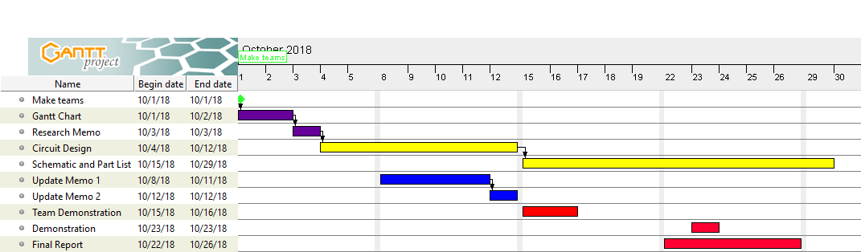

Here we have our updated Gantt chart. This chart has been updated to match the deadlines being extended. For example the Circuit Design memo was pushed back until October 15th. With an updated Gantt chart we will be able to plan the project out more efficiently

**Updated WBS:**

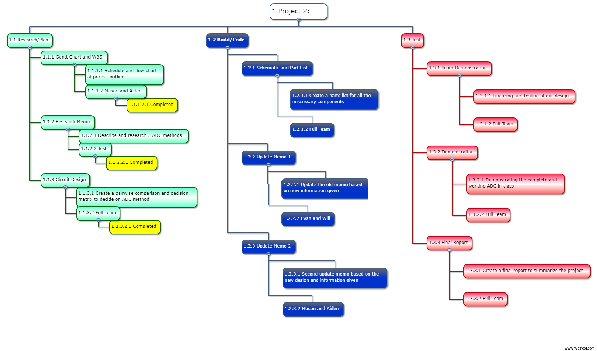

With an updated WBS chart we are able to keep track of what has been completed and what still needs to be worked on. In the chart we can see the completed items in the research/plan branch marked in yellow. Our next step is to start to build and code the project.

**Conclusion:**

With an updated WBS and Gantt chart, our team now has a clear and concise timeline of our duties and outline of the project due dates. We have made much progress into this project and are almost ready to start assembling our flash converter ADC.

**Attachments:** None